**ReactJS-HOL**

**Create scorecalculatorapp with a Functional Component**

**Step 1: Create the React App**

1. Open **VS Code**
2. Open a new folder for the project
3. Open Terminal → Terminal → New Terminal
4. Run:

npx create-react-app scorecalculatorapp

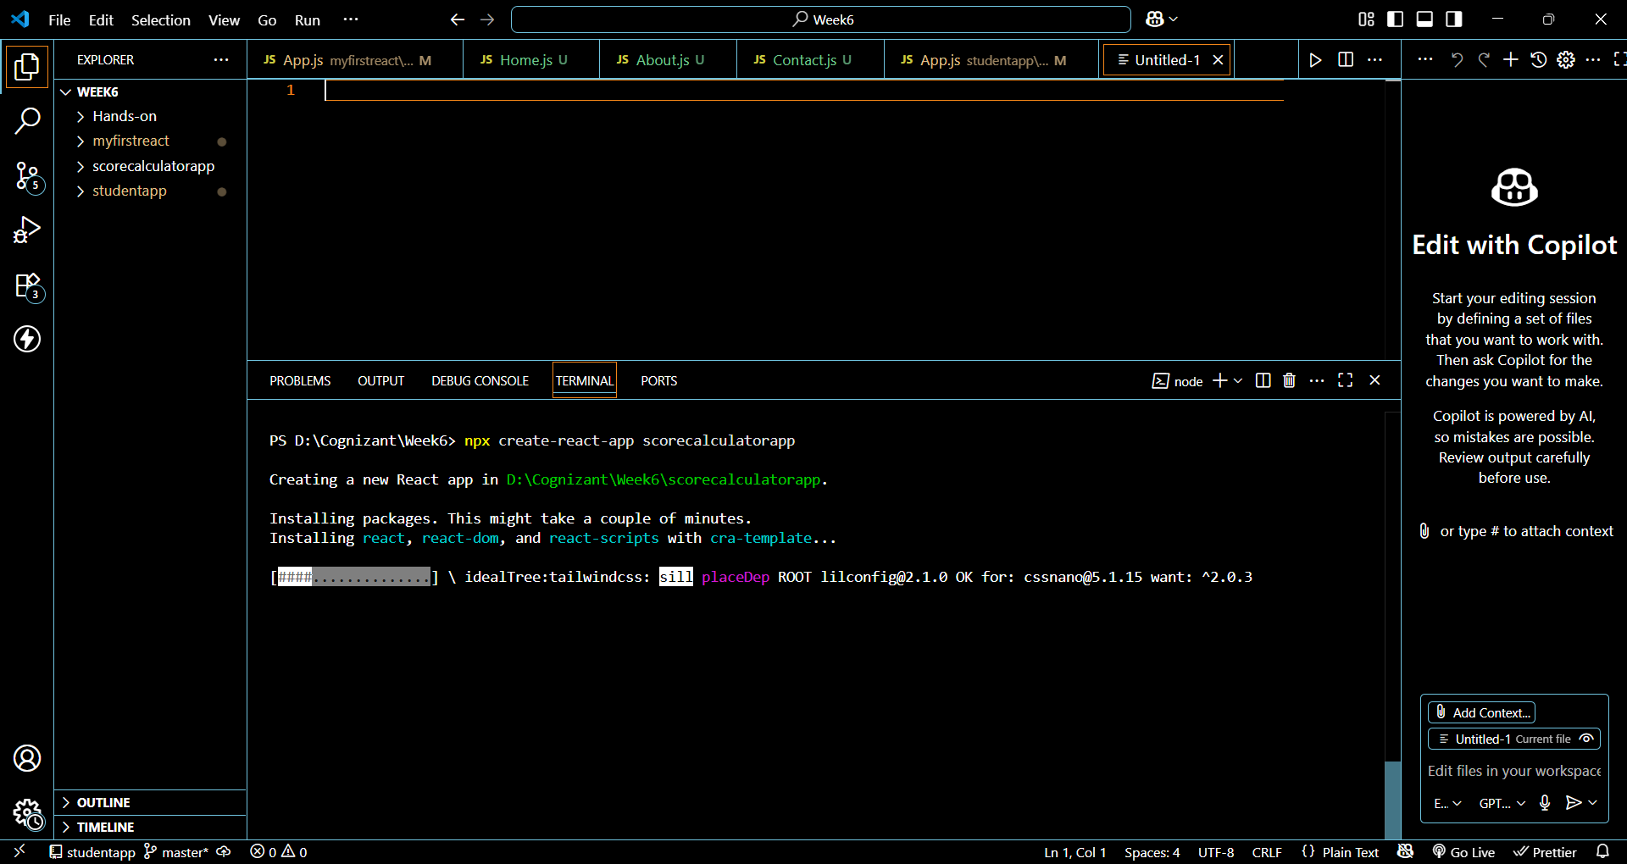

**Step 2: Move Into the Project Directory**

cd scorecalculatorapp

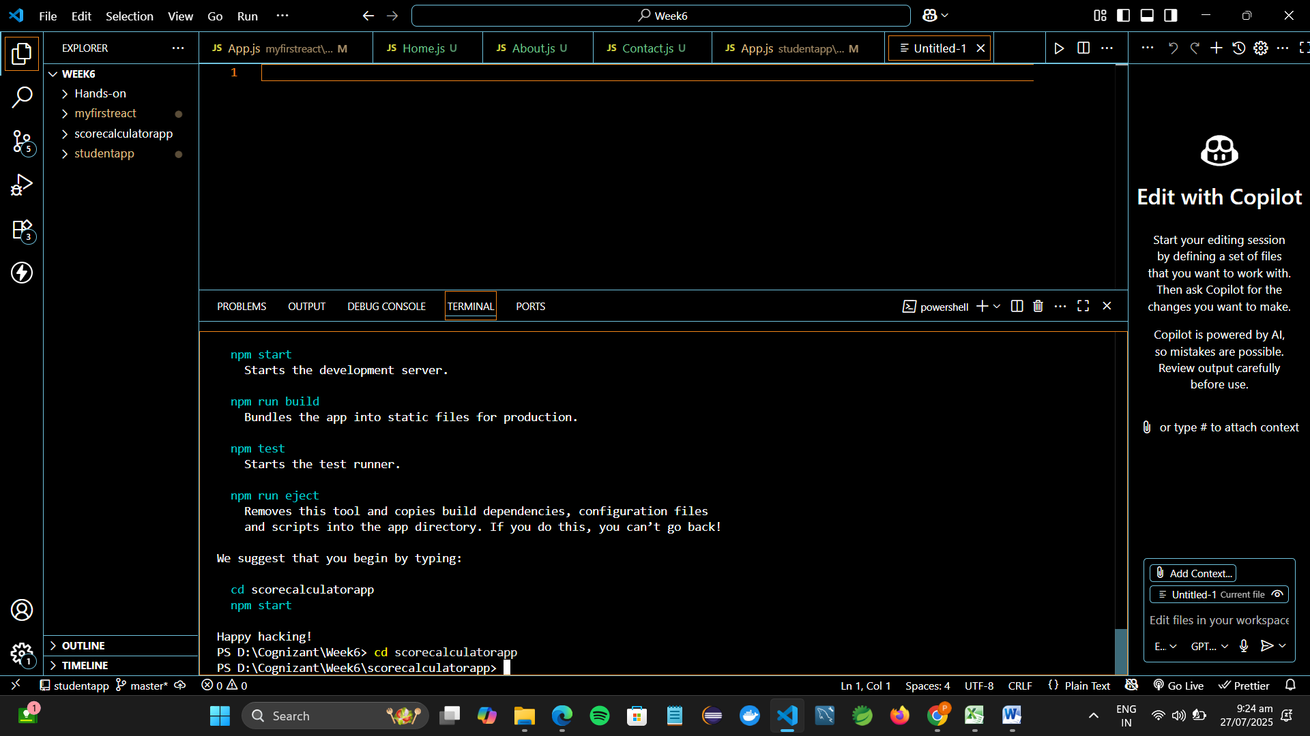

**Step 3: Create Functional Component CalculateScore**

1. Inside src, create a folder named:

Components

1. Inside Components, create a file:

CalculateScore.js

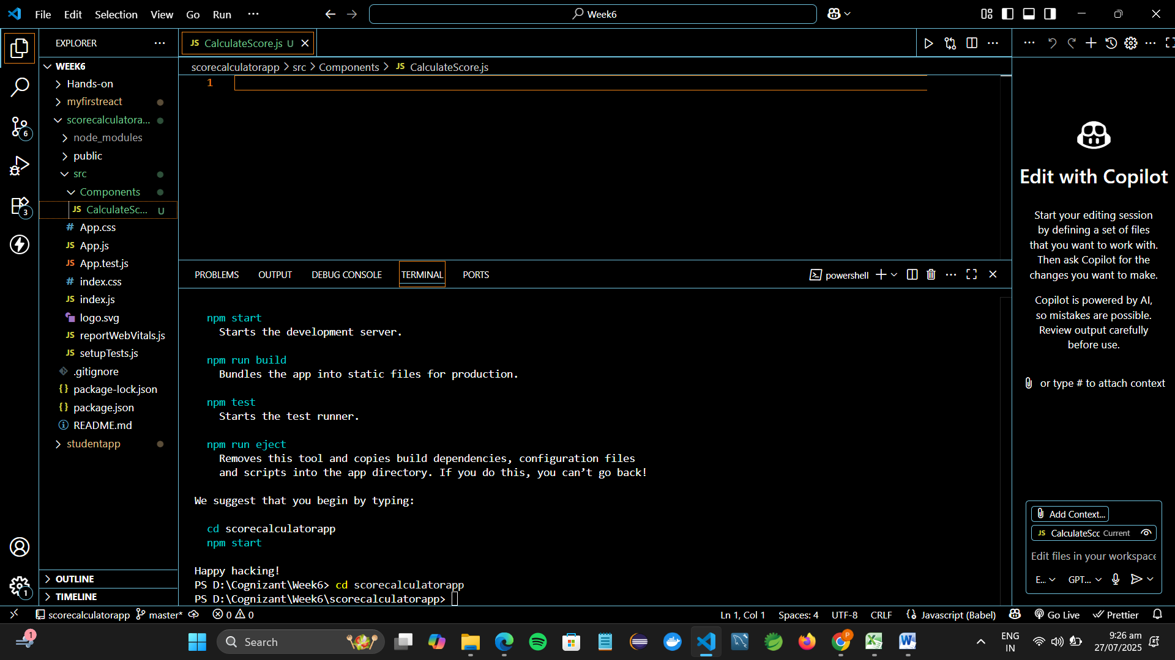

1. Add the following code to CalculateScore.js:

import React from 'react';

import '../Stylesheets/mystyle.css';

function CalculateScore() {

const name = "Pooja";

const school = "SKCET";

const total = 450;

const goal = 500;

const average = (total / goal) * 100;

return (

<div className="score-container">

<h2>Student Score Calculator</h2>

<p><strong>Name:</strong> {name}</p>

<p><strong>School:</strong> {school}</p>

<p><strong>Total Marks:</strong> {total}</p>

<p><strong>Goal:</strong> {goal}</p>

<p><strong>Average Score:</strong> {average.toFixed(2)}%</p>

</div>

);

}

export default CalculateScore;

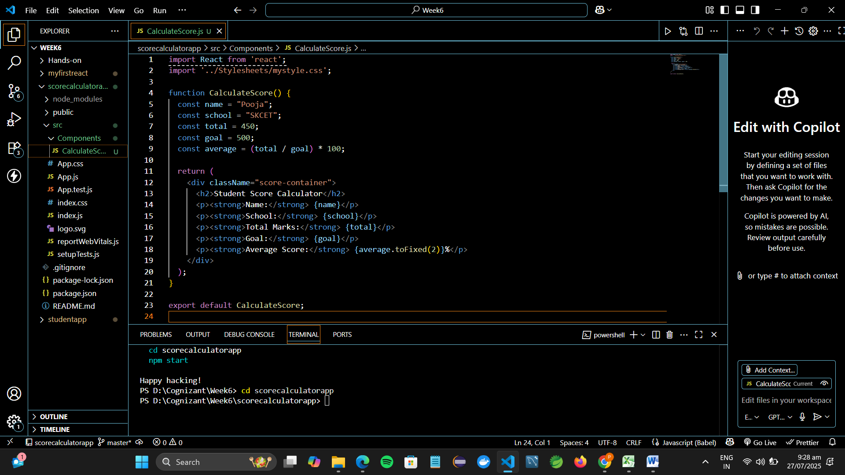

**Step 4: Add Styling with mystyle.css**

1. Inside src, create a folder:

Stylesheets

1. Inside Stylesheets, create a file:

mystyle.css

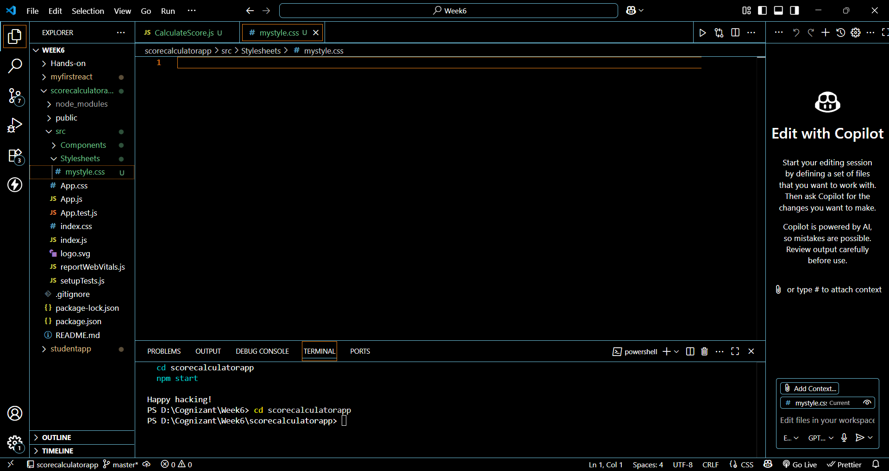

1. Add some styles:

.score-container {

background-color: #f5f5f5;

border: 2px solid #4caf50;

padding: 20px;

width: 400px;

margin: 40px auto;

border-radius: 10px;

text-align: left;

font-family: 'Arial', sans-serif;

}

.score-container h2 {

color: #4caf50;

text-align: center;

}

.score-container p {

font-size: 16px;

margin: 8px 0;

}

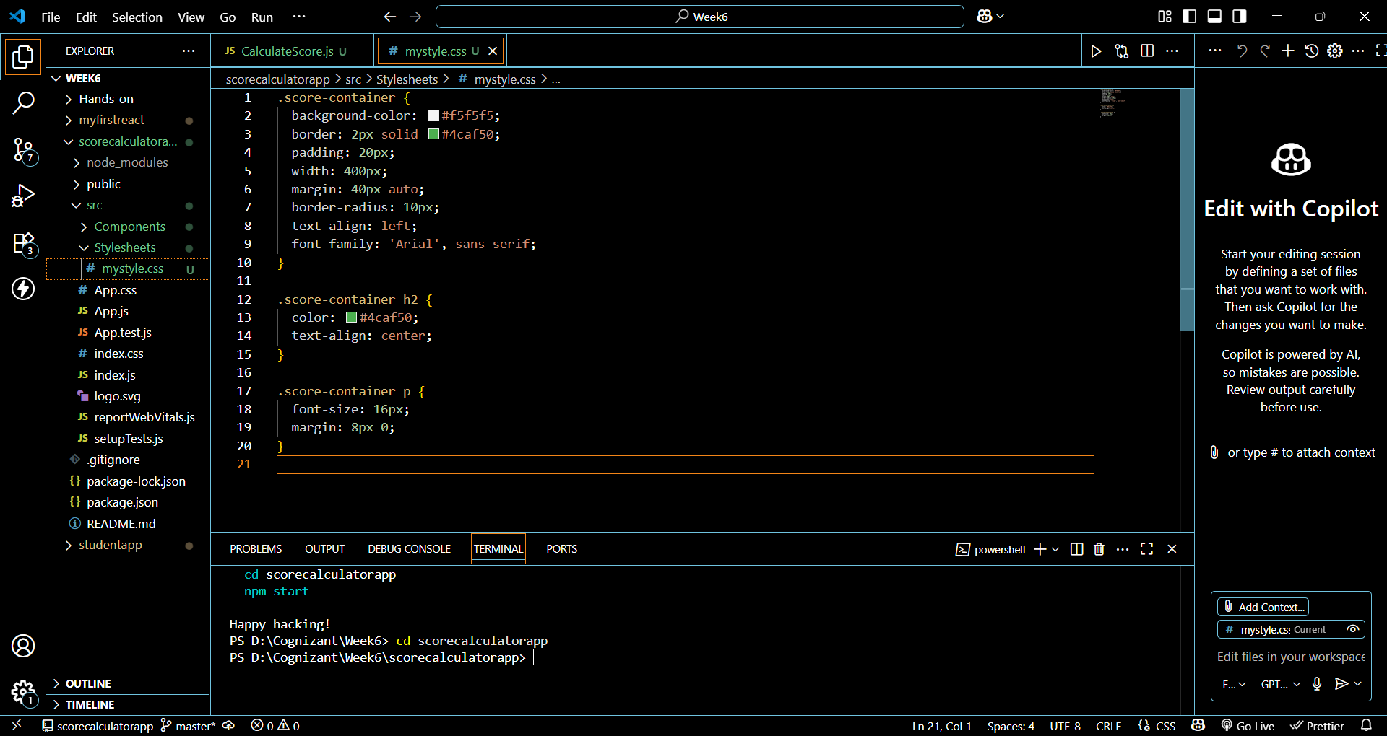

**Step 5: Edit App.js to Render the Component**

In src/App.js, replace everything with:

import React from 'react';

import CalculateScore from './Components/CalculateScore';

function App() {

return (

<div className="App">

<CalculateScore />

</div>

);

}

export default App;

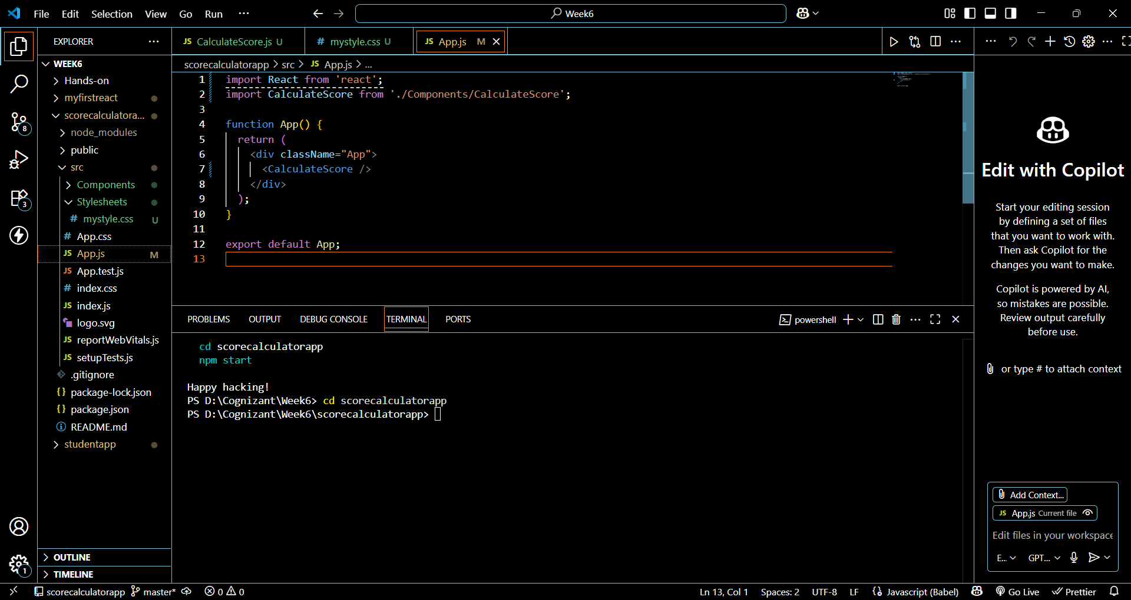

**Step 6: Run the App**

In terminal (inside scorecalculatorapp folder), run:

npm start

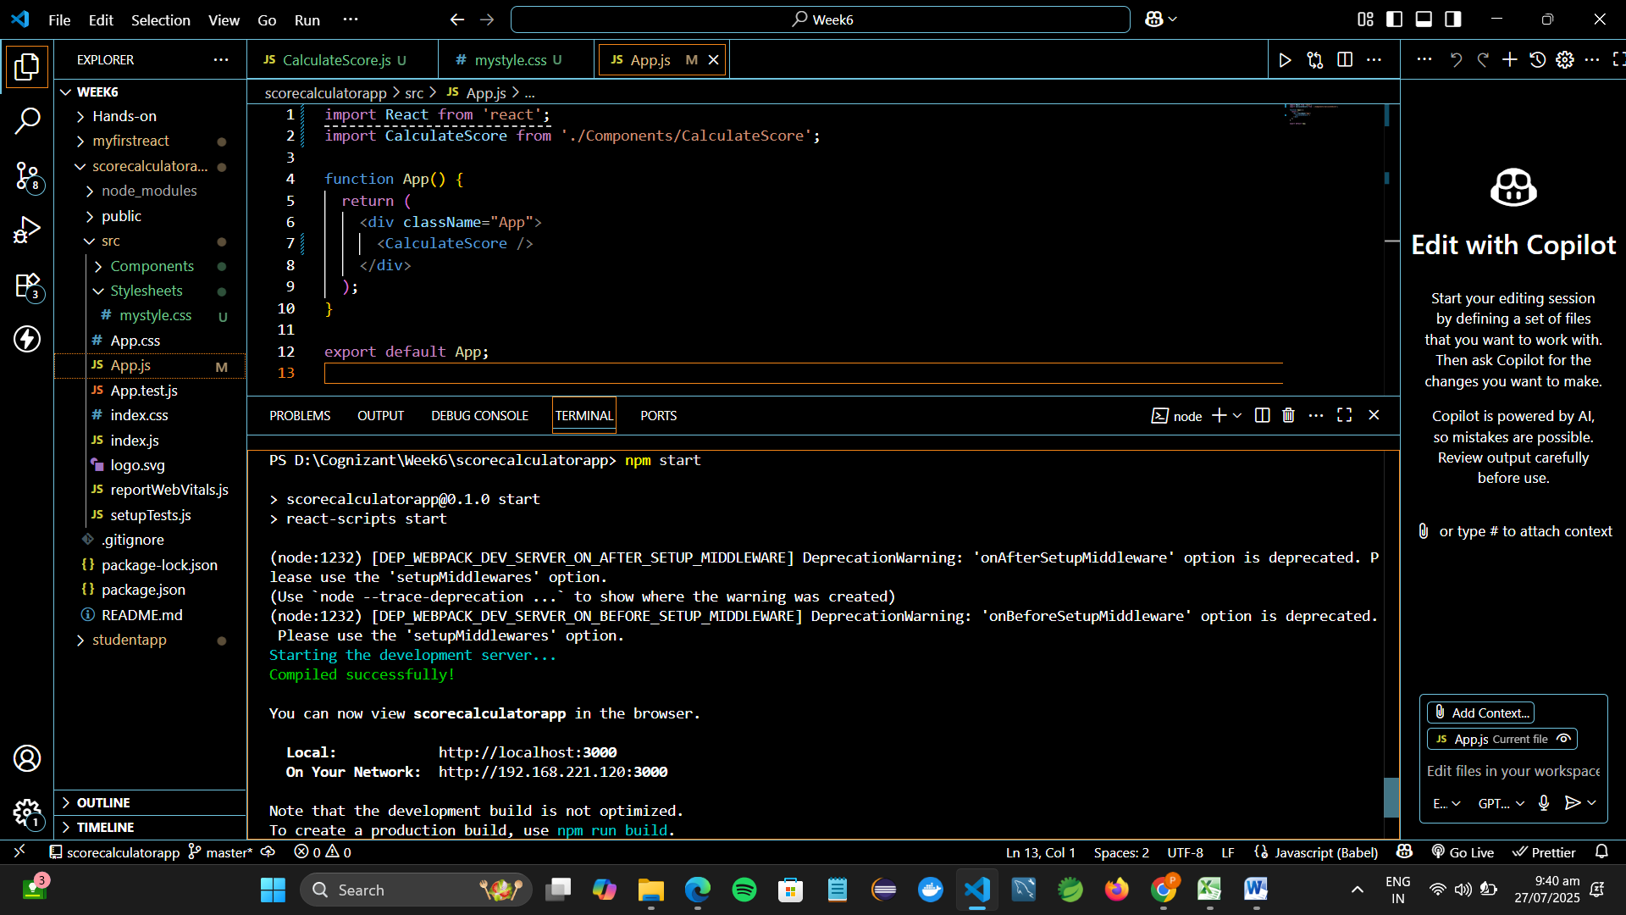

**Step 7: View in Browser**

Open a browser and visit:

http://localhost:3000

You should see a styled box showing:

* Student name
* School name
* Total marks
* Goal
* Calculated average in %

**Result:**

